HOSPITAL APPOINTMENT MANAGEMENT SYSTEMS.

JOTHAM KIMUTAI KIPCHUMBA.

A research project submitted to the school of science, Engineering, and Technology in partial fulfillment of the requirements for the award of Diploma in Information Technology, kabarak university

December, 2025

COPYRIGHT
© 2025
All rights reserved.
No portion of this project may be copied, reproduced, stored in a retrieval system, or transmitted in any form or by any means whether electronic, mechanical, photocopying, recording, or otherwise without prior written permission from the author or Kabarak University on that.
Sign: ............................................. Date: .........................................

DECLARATION AND APPROVAL.
I hereby declare that this research project is my original work and has not been submitted to the Faculty of Information Technology or any other institution for academic or professional purposes. No section of this document may be reproduced or used without proper authorization.
Sign: .................................................... Date: ..............................................
Student: Jotham. k. Kipchumba.
Registration Number: DIT/N/0800/05/24

RECOMMENDATION
This research project titled Hospital Appointment Management System, prepared by Jotham.k.kipchumba is hereby submitted to the School of Science, Engineering and Technology, Kabarak University. Having reviewed the work thoroughly, I find it satisfactory and therefore recommend it for acceptance as part of the requirements for the award of the Diploma in Information Technology.

Signature: ___________________________ Date: ___________________________
Mr. Elvine Saikwa,
School of Science, Engineering and Technology,
Department of Computer Science and Information Technology,
Kabarak University.

ACKNOWLEDGMENT
I would like to express my deepest gratitude to the Almighty God for the gift of life, strength, and guidance throughout the completion of this project. My sincere appreciation goes to my supervisor, Mr. Elvine Saikwa, for his continuous support, valuable advice, and encouragement that made this work possible. I am also thankful to the lecturers and staff of the School of Science, Engineering and Technology, Department of Computer Science and Information Technology, Kabarak University, for their dedication and support during my study period. Special thanks go to my family and friends for their moral and financial support, patience, and understanding throughout this journey. Their belief in me has been a great source of motivation and inspiration. Finally, I acknowledge all individuals who, in one way or another, contributed to the successful completion of this research project.

Jotham.K.Kipchumba.
DIT/N/0800/05/24

DEDICATION
I dedicate this work to my beloved parents and family for their constant encouragement, love, and unwavering support. Their sacrifices and prayers have been the foundation of my success.

Jotham.K.Kipchumba.

ABSTRACT
The Hospital Appointment Management System is a web-based solution designed to simplify and automate the process of scheduling and managing hospital appointments. The traditional manual system often results in long queues, misplaced patient records, and inefficient communication between patients and healthcare providers. This project aims to address these challenges by developing an online platform that allows patients to book, reschedule, or cancel appointments conveniently while enabling hospital administrators and doctors to manage schedules efficiently. It features secure user authentication, appointment tracking, doctor availability management, and notification alerts to enhance communication. Through the implementation of this system, hospitals can achieve improved service delivery, reduced waiting times, accurate record-keeping, and better resource utilization. The project demonstrates how information technology can be effectively applied to improve healthcare operations and patient satisfaction.
Keywords: HASM

TABLE OF CONTENTS.
COPYRIGHT ii
DECLARATION AND APPROVAL iii
RECOMMENDATION iv
ACKNOWLEDGMENT v
DEDICATION vi
ABSTRACT vii
LIST OF FIGURES xi
LIST OF ABBREVIATIONS. xii
LIST OF TABLES. xiii
CHAPTER ONE 1
INTRODUCTION 1
1.1Introduction 1
1.2 Background to the Study 2
1.3 Statement of the Problem 3
1.4 Purpose of the Study. 3
1.5 General objective. 3
1.5.1 Specific Objectives. 3
1.6 Research Questions 3
1.7 Justification for the Study. 4
1.8 Scope of the Study. 4
1.9 Limitations of the Study. 4
1.10 Assumptions of the Study 4
CHAPTER TWO 5
LITERATURE REVIEW 5
2.1 Introduction 5
2.2 Global Perspective on Hospital Appointment Systems 5
2.3 Regional (African) Context 5
2.4 Research Gaps 6
2.5 Conceptual Framework. 6
CHAPTER THREE 9
RESEARCH METHODOLOGY 9
3.1 Introduction. 9
3.1.1 System Development Methodology 9
3.1.2 Requirement Analysis. 9
3.1.3 Design. 10
3.1.4 Development. 10
3.1.5 Testing. 10
3.1.6 Maintenance. 10
3.1.7 Feedback. 10
3.2 Justification of Methodology. 10
3.2.1 Functional Requirements. 10
3.2.2 User Login and Authentication. 11
3.2.3 Appointment Booking and Management. 11
3.2.4 Display of Records. 11
3.2.5 Record Storage. 11
3.3 Non-Functional Requirements. 11
3.3.1 Usability. 11
3.3.2 Reliability. 11
3.3.3 Security. 11
3.4 Tools and Techniques. 11
3.4.1 Visual Studio Code (VS Code). 12
3.4.2 CSS. 12
3.4.3 PHP. 12
3.4.4 MySQL. 12
3.4.5 XAMPP. 12
3.4.6 Microsoft Word. 12
3.5 Data Collection Methods. 12
3.5.1 Primary Data Collection Methods. 12
3.5.2 Secondary Data Collection Methods. 12
3.6 Data Flow Diagram. 13
3.7.1 Context Diagram – Level 0. 13
3.7.2 DFD Diagram – Level 1 13
CHAPTER FOUR 15
SYSTEM ANALYSIS, IMPLEMENTATION AND DESIGN 15
4.0 Introduction. 15
4.1 Input Design 15
4.1.1 User Login Screen. 15
4.1.2 Appointment Booking Form. 16
4.1.3 Dashboard Screen 16
4.1.4 Admin module. 18
4.1.5 Admin dashboard. 19
4.1.6 Manage User Pages. 19
4.1.7 Appointment overview page. 20
4.1.8 Doctor’s Module. 21
4.1.9 Doctor’s dashboard. 22
4.1.10 Viewing Appointment Schedule. 22
4.1.11 Patient Module. 23
4.1.12 Appointment Booking Page. 24
4.1.13 Appointment Status Page. 25
4.2 Description of the Implementation. 26
4.2.1 Hardware Specification. 26
4.2.2 Software Specification. 26
4.3 Description of Testing and Results. 26
4.3.1 System Testing. 26
4.3.2 Testing and Data Results. 26
4.3.3 Non-Functional Requirements. 27
4.4.4. Description of Results. 27
CHAPTER FIVE. 28
CONCLUSION AND RECOMMENDATION. 28
5.0 Introduction 28
5.1 Conclusion 28
5.2 Recommendation. 28
5.3 Future Works. 29
REFERENCES. 30

LIST OF FIGURES
Figure 1:Conceptual framework 8
Figure 2:Waterfall methodology. 9
Figure 3:Context Diagram. 13
Figure 4:DFD-Diagram. 14
Figure 5 User Login. 16
Figure 6 Dashboard Screen. 17
Figure 7 Admin login page. 18
Figure 8 Admin Dashboard. 19
Figure 9 manage user pages. 19
Figure 10 Patient bookings. 20
Figure 11 Doctor’s login page. 21
Figure 12 Doctor’s dashboard. 22
Figure 13 Viewing Appointment Schedule. 22
Figure 14 Patient register& login 23
Figure 15 Appointment booking page. 24
Figure 16 Appointment status page. 25

LIST OF ABBREVIATIONS.
HASM- Hospital Appointment System Management
CSS-Cascading Style Sheet
HTML-Hyper Text Markup Language
SQL-Structured Querry Language
CPU-Central Processing Unit
DBMS-Database Management System
DFD-Data Flow Diagrams
HTTP-Hypertext Transfer Protocol
LAN-Local Area Network
SDLC-System Development Life Cycle

LIST OF TABLES.
Table 1:Research Gaps. 6
Table 2 Testing and Data results. 18
Table 3 Non-Functional requirements. 19

CHAPTER ONE

INTRODUCTION

1.1Introduction
Healthcare is one of the most critical sectors in any country, as it deals directly with the well-being and survival of human life. Over the years, hospitals have evolved from small local dispensaries to complex institutions offering a wide range of specialized medical services (World Health Organization, 2021). One of the core challenges that continues to face healthcare institutions, especially in developing countries like Kenya, is the management of hospital appointments and patient flow.
According to (Otieno, 2023), hospital appointment management refers to the process of scheduling, rescheduling, and organizing patient consultations with medical practitioners in an efficient and timely manner. The goal is to minimize patient waiting times, ensure proper time allocation for doctors, and optimize overall hospital operations. (Karanja, 2022) defines a hospital appointment system as a digital or manual structure used by healthcare institutions to coordinate patient visits, store records, and manage consultation schedules.
In the past, most hospitals relied on manual record-keeping and in-person bookings, where patients had to physically visit the hospital to secure an appointment. This process was time-consuming and often led to overcrowding, poor service delivery, and administrative inefficiencies (Mwangi, 2021). With the growth of information technology, healthcare institutions across the world have started adopting digital management systems that automate and streamline daily hospital operations (Muthoni, 2023).
Globally, the introduction of digital appointment systems has transformed how hospitals manage patient interactions. Systems developed in countries such as the United Kingdom and India have shown significant improvements in reducing patient waiting times, improving data accuracy, and enhancing communication between healthcare providers and patients (Smith & Jones, 2020).
In Kenya, the Ministry of Health has encouraged the integration of Information and Communication Technology (ICT) in healthcare institutions to support efficient and transparent service delivery (Kariuki & Mutua, 2022). Hospitals such as Kenyatta National Hospital and Moi Teaching and Referral Hospital have implemented basic digital systems to manage patient information and appointments, although many smaller hospitals still depend on manual processes.
The proposed Hospital Appointment Management System (HAMS) seeks to address these challenges by providing a centralized, web-based platform for managing hospital appointments. The system will allow patients to book, reschedule, or cancel appointments online, while doctors and administrators will have tools to view, confirm, and manage schedules efficiently. By automating this process, hospitals can reduce congestion, enhance record accuracy, and improve overall service delivery (World Health Organization, 2021).

1.2 Background to the Study
Globally, healthcare institutions are increasingly adopting digital systems to enhance service delivery, reduce waiting time, and improve patient satisfaction. According to the World Health Organization (WHO, 2024), over 70% of developed countries have integrated e-health systems to manage appointments, records, and patient-doctor interactions. Countries such as the United Kingdom and Canada have hospital management portals that allow patients to schedule appointments, receive reminders, and access their medical history online, resulting in reduced congestion and improved healthcare efficiency.
Regionally, in Africa, the digital transformation of healthcare is growing but still limited. A report by the African Health Observatory (2023) indicates that most public hospitals in Sub-Saharan Africa still rely on manual appointment booking—patients must queue physically to register and wait to see a doctor. This process leads to long waiting hours, misplaced records, and inefficient time management by medical staff.
In Kenya, the Ministry of Health has introduced initiatives such as the Afya KE portal and eHealth Strategy (2023–2027) aimed at digitizing health services. However, most county and referral hospitals still face major challenges in managing appointments due to manual record systems, overcrowding, and lack of automation. Research by the Kenya Healthcare Federation (2024) shows that over 60% of patients in public hospitals wait for more than two hours before seeing a doctor, mainly due to poor scheduling and inefficient patient flow management.
This study focuses on developing a Hospital Appointment Management System (HAMS) to automate the scheduling of doctor–patient appointments. The system will enable patients to book appointments online, receive SMS or email confirmations, and allow hospitals to manage schedules efficiently. By leveraging technology, the system seeks to minimize congestion, reduce administrative workload, and improve patient experience across Kenyan hospitals.

1.3 Statement of the Problem
Most hospitals in Kenya still rely on manual procedures for booking appointments, which involve filling physical forms or queuing early in the morning to see a doctor. This causes long waiting times, mismanagement of patient flow, and staff overload. The absence of an integrated digital appointment system leads to missed appointments, poor time utilization, and patient dissatisfaction. If the issue is not addressed, it will continue to compromise healthcare quality, increase operational costs, and discourage patients from seeking timely medical care.

1.4 Purpose of the Study.
The purpose of this study is to design and develop a Hospital Appointment Management System that automates the process of booking, confirming, and managing hospital appointments to enhance efficiency and patient satisfaction in healthcare service delivery.

1.5 General objective.
To design and implement a Hospital Appointment Management System for efficient scheduling and management of patient appointments.

1.5.1 Specific Objectives.
- To identify the challenges associated with manual hospital appointment booking in Kenyan hospitals.
- To determine the system requirements for an automated hospital appointment management system.
- To design and develop a prototype system that enables online scheduling and tracking of appointments.

1.6 Research Questions
- What are the major challenges facing hospitals in managing appointments manually?
- What functional and non-functional requirements are needed for an automated hospital appointment management system?
- How can a web-based or mobile system be designed to simplify patient appointment scheduling and tracking?

1.7 Justification for the Study.
The Hospital Appointment Management System (HAMS) is designed to improve hospital efficiency by automating appointment booking and scheduling. Manual systems often cause delays, congestion, and data errors. By digitizing this process, hospitals can reduce waiting times, enhance patient satisfaction, and improve communication between patients and healthcare providers. The system also supports better data management and decision-making in hospital operations.

1.8 Scope of the Study.
This study focuses on the design and development of a web-based Hospital Appointment Management System . It will cover patient registration, appointment booking, schedule management, and notification of confirmed appointments. The system will also include modules for doctors to view and manage their appointments, and for administrators to oversee users, records, and reports.

1.9 Limitations of the Study.
- Limited internet access in rural hospitals, which may affect real-time booking.
- User resistance from staff accustomed to manual methods.
- Data security and privacy concerns when handling patient information.
To mitigate these, the system will use secure authentication, offline caching options, and user training sessions for adoption.

1.10 Assumptions of the Study
The assumption made throughout the study was that the Hospital appointment management system would be an effective tool for patients and healthcare providers to manage ,schedule and track medical appointments efficiently.

CHAPTER TWO

LITERATURE REVIEW

2.1 Introduction
This chapter reviews existing literature related to hospital appointment management systems. It discusses global trends in healthcare digitization, regional and Kenyan perspectives, and existing systems and technologies used to manage hospital appointments. The review identifies gaps in current practices that justify the need for a smart, automated hospital appointment management system. The chapter also presents the conceptual framework that guided the development of the proposed system.

2.2 Global Perspective on Hospital Appointment Systems
Globally, the healthcare industry has undergone significant digital transformation aimed at improving patient experience and reducing operational inefficiencies. According to the World Health Organization (WHO, 2024), developed countries have adopted digital health management systems that integrate appointment scheduling, patient record management, and telemedicine.
In the United States, hospitals use systems such as EpicCare and Cerner Millennium to automate appointment booking, reduce waiting time, and improve communication between doctors and patients. Patients can schedule, reschedule, or cancel appointments through mobile apps or web portals. These systems also generate automated reminders via email or SMS to reduce missed appointments.
Similarly, in the United Kingdom, the National Health Service (NHS) operates a centralized appointment platform that allows patients to book hospital visits, choose specialists, and view appointment history. The introduction of NHS e-Referral Service has improved appointment adherence by 35%, according to NHS Digital (2023).
These global systems demonstrate that automating hospital appointment management improves operational efficiency, enhances patient satisfaction, and reduces congestion in healthcare facilities.

2.3 Regional (African) Context
In many African countries, healthcare institutions are gradually transitioning to digital management systems. According to the African Health Observatory (2023), fewer than 30% of public hospitals in Sub-Saharan Africa have adopted electronic appointment systems. The majority still rely on manual scheduling and paper-based records.
In South Africa, hospitals such as the Steve Biko Academic Hospital have piloted online appointment systems that allow patients to book visits using mobile devices. The system integrates patient records, appointment history, and physician schedules. Similarly, in Nigeria, researchers developed an SMS-based appointment system to reduce overcrowding in hospitals, but the system lacked real-time synchronization with hospital databases.
Despite these efforts, most African healthcare systems face barriers such as poor ICT infrastructure, lack of technical expertise, and limited funding. This creates a gap that can be addressed by lightweight, scalable, and locally adaptable systems.

2.4 Research gaps
Table 1:Research Gaps.
Author | Name of system | Strength of system | Weakness of system
Ministry of Health (2023) | Kenya Health information system | Centralized data collection reporting at national level | Does not support real-time appointment scheduling for hospitals.
Aga Khan University Hospital(2024) | One Health Digital system | Efficient in handling electronic medical records | Limited to private facilities and not scalable to public hospitals.
Nakuru county smart Health project (2024) | Smart clinic booking App | Enable urban hospital booking | Lacks offline capability and integration with hospital database

2.5 Conceptual Framework.
The conceptual framework illustrates how different components of the Hospital Appointment Management System interact to achieve efficient healthcare service delivery. The process begins with patients who can book, cancel, or view appointments through the Hospital Appointment System interface. This central system processes patient requests and communicates with two main functional modules the Doctor Module and the Admin Module.
- The Doctor Module allows doctors to view their schedules, manage appointments, and update consultation details.
- The Admin Module handles overall system management tasks, such as user registration, doctor allocation, and monitoring of hospital activities.
Both modules interact with the Database, which stores all essential information including patient records, appointment data, and system notifications. From this database, the system generates Reports and Feedback, which help in improving hospital operations, decision-making, and patient satisfaction.
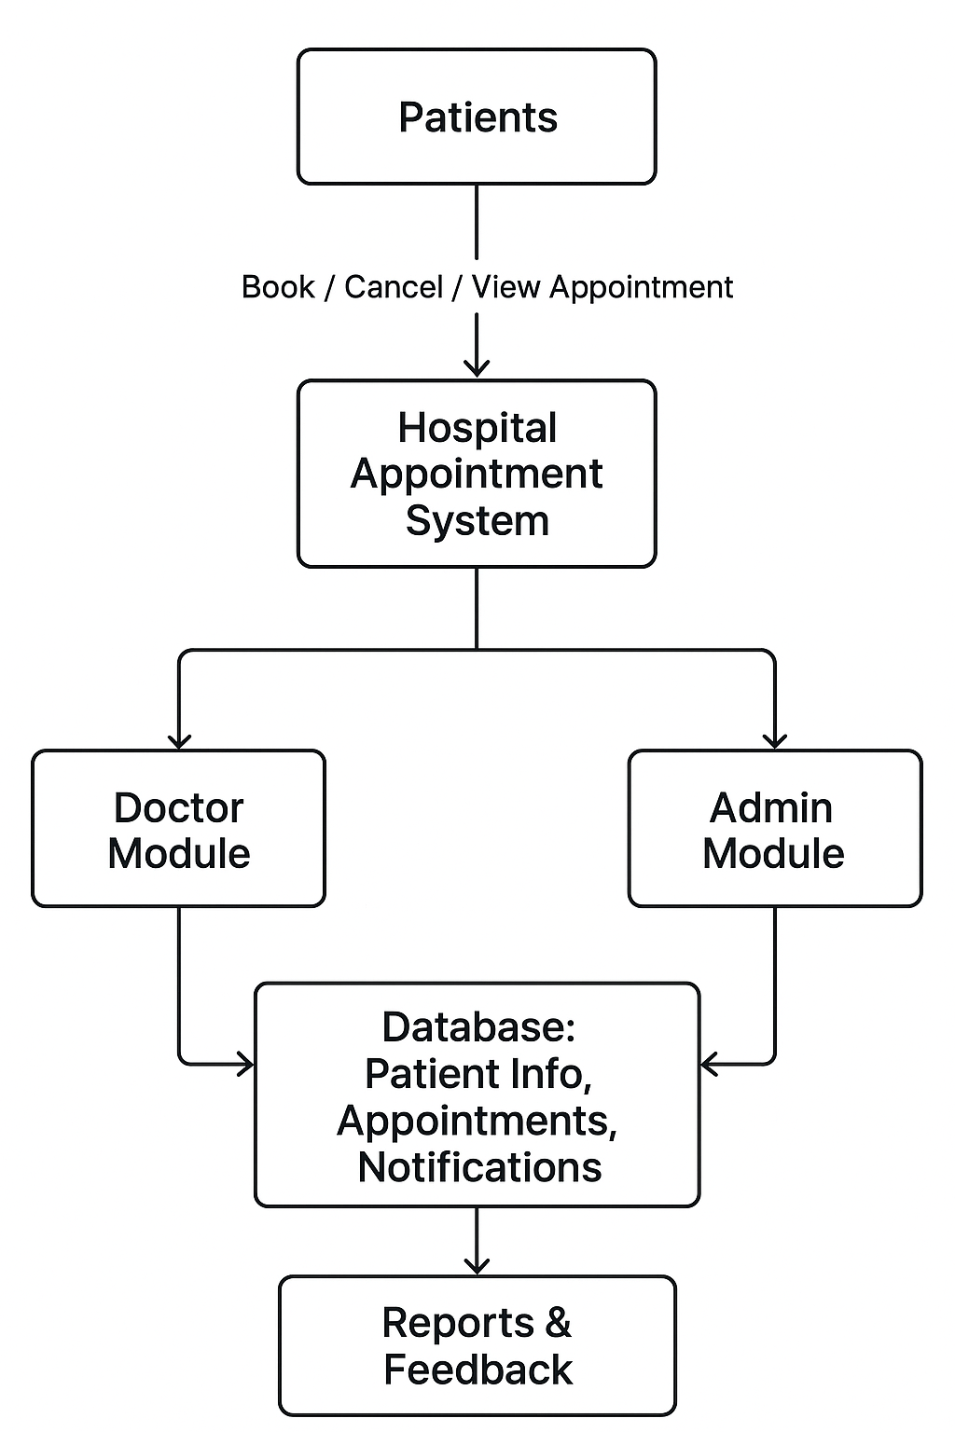
Figure 1:Conceptual framework

CHAPTER THREE

RESEARCH METHODOLOGY

3.1 Introduction.
This chapter discusses the methods and procedures used in developing the Hospital Appointment Management System (HAMS). It outlines the system development methodology, justification of the chosen approach, functional and non-functional requirements, tools and technologies used, milestones and deliverables, and data collection methods. It also presents data flow diagrams that illustrate the logical flow of operations within the system.

3.1.1 System Development Methodology
The development of the Hospital Appointment Management System followed the Waterfall Model of the Software Development Life Cycle (SDLC). This model was chosen because it allows systematic progression through phases, ensuring each stage is completed before moving to the next.
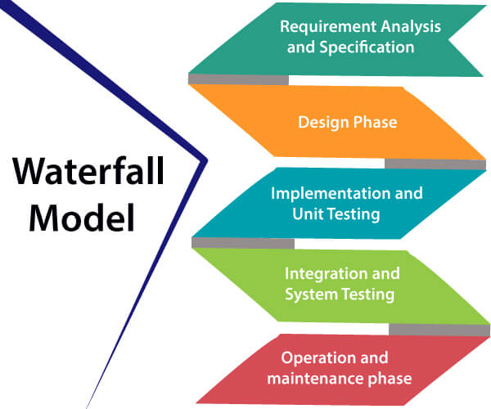
Figure 2:Waterfall methodology.

3.1.2 Requirement Analysis.
In this phase, user and system requirements were gathered from hospital staff, doctors, and patients. The key requirements identified include patient registration, appointment booking, doctor scheduling, and report generation.

3.1.3 Design.
The system design involved creating Data Flow Diagrams (DVDs), Entity Relationship Diagrams (Erds), and user interface sketches. The database structure was also designed to manage patient information, appointment details, and system users efficiently.

3.1.4 Development.
The development of the Hospital Appointment Management System (HAMS) was carried out using PHP for the backend and MySQL for the database. The system was built in modules, starting with the login system, dashboard, and appointment management module. Each feature was tested step-by-step to ensure it functioned as expected and allowed patients and hospital staff to efficiently manage hospital appointments and schedules digitally.

3.1.5 Testing.
Testing was conducted to ensure the system functioned correctly. Unit testing and system testing were used to identify and fix errors. User acceptance testing was also performed by allowing hospital staff and patients to test the system’s usability and functionality.

3.1.6 Maintenance.
This phase involves future system improvements based on user feedback and technological advancements. Updates may include fixing bugs, adding new features, and enhancing system performance.

3.1.7 Feedback.
User feedback was collected to assess satisfaction levels, identify system challenges, and determine areas needing improvement.

3.2 Justification of Methodology.
The Waterfall Model was chosen because it provides a structured and clear framework that simplifies documentation and management of each development stage. It ensures all requirements are defined early and changes are minimized during later stages, which is suitable for developing small to medium-sized projects like the Hospital Appointment Management System.

3.2.1 Functional Requirements.
This section highlighted the functionality of the Hospital Appointment system management .

3.2.2 User Login and Authentication.
Only authorized users can access the system. The authentication system ensures secure access and prevents unauthorized users from accessing system data.

3.2.3 Appointment Booking and Management.
Patients can book appointments with available doctors based on time slots. The system checks doctor availability before confirming the appointment.

3.2.4 Display of Records.
Users can view records such as patient details, appointment history, and doctor schedules. Administrators can monitor all records within the system.

3.2.5 Record Storage.
All data is stored in a secure database using MySQL. This ensures easy data retrieval, editing, and deletion when necessary.

3.3 Non-Functional Requirements.

3.3.1 Usability.
The system has a user-friendly interface that allows easy navigation for both patients and hospital staff.

3.3.2 Reliability.
The system provides consistent performance and accurate appointment management under normal operating conditions.

3.3.3 Security.
User authentication, encrypted passwords, and controlled access ensure data confidentiality and system security.

3.4 Tools and Techniques.
This section outlines the various tools and technologies that were used in the development of the Hospital Appointment Management System (HAMS). The selection of tools was based on their compatibility, ease of use, efficiency, and ability to support web-based system development.

3.4.1 Visual Studio Code (VS Code).
This is the primary code editor for writing and managing the system’s source code.

3.4.2 CSS.
Used for styling web pages and improving user interface aesthetics.

3.4.3 PHP.
Used as the backend programming language to handle server-side operations and database interactions.

3.4.4 MySQL.
Serves as the database management system for storing and managing system data.

3.4.5 XAMPP.
Provides a local server environment for running PHP and MySQL during development and testing.

3.4.6 Microsoft Word.
Used for project documentation and report preparation.

3.5 Data Collection Methods.
Data collection was essential in identifying user needs and evaluating the system’s effectiveness.

3.5.1 Primary Data Collection Methods.
Primary data was collected through interviews and questionnaires given to hospital staff, doctors, and patients. The main purpose of using primary data collection methods is to obtain accurate and current information directly from respondents who are directly involved in the hospital appointment process. This helps in understanding real-world problems, user expectations, and system requirements.

3.5.2 Secondary Data Collection Methods.
Secondary data was obtained from journals, online publications, and previous research related to healthcare information systems and digital appointment platforms.

3.6 Data Flow Diagram.

3.7.1 Context Diagram – Level 0.
The context diagram illustrat8es the overall interaction between the user and the system. The main external entities are the Patient, Doctor, and Administrator. Patients make appointment requests, which are processed by the system and managed by the admin and doctor modules.
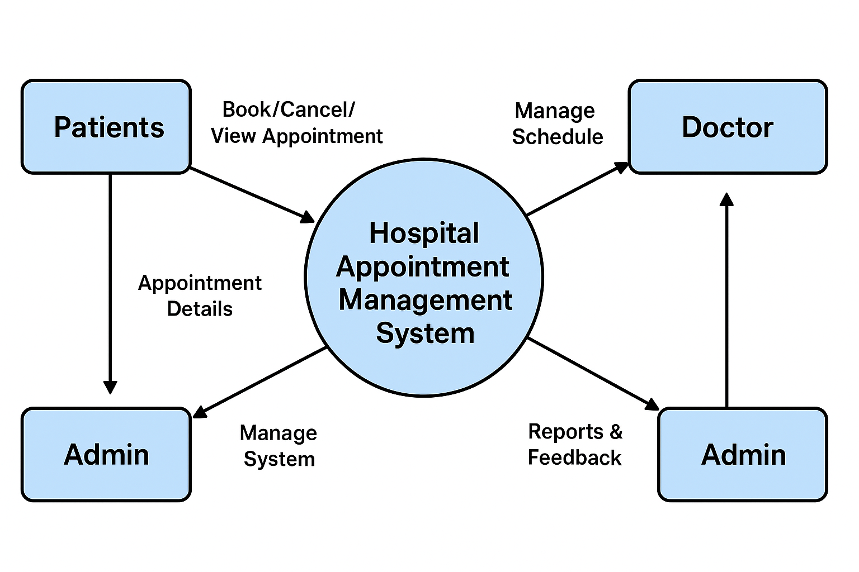
Figure 3:Context Diagram.

3.7.2 DFD Diagram – Level 1
The Level 1 DFD expands the context diagram to show internal processes such as patient registration, appointment management, and report generation. It highlights data movement between the modules and the database.
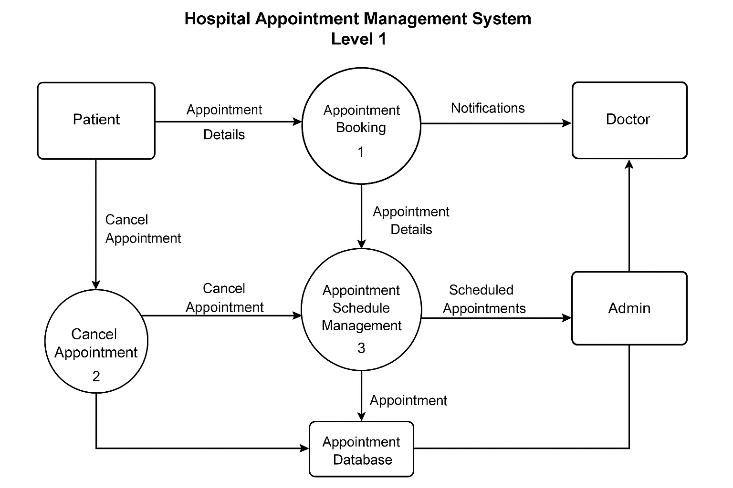
Figure 4:DFD-Diagram.

CHAPTER FOUR

SYSTEM ANALYSIS, IMPLEMENTATION AND DESIGN

4.0 Introduction.
This chapter provides an in-depth explanation of the system’s functionality and incorporates the diagrams and models that illustrate how the Hospital Appointment management system operates.it also highlights the implementation and testing processes carried out during the development phase System implementation describes the procedures followed in constructing and deploying the information system, including the configuration of modules and integration of various components. On the other hand, system testing involves subjecting the fully integrated system to a series of tests to determine whether it meets the specified requirements and performs as expected. This ensures that the system is reliable, functional, and ready for use.
4.1 Input Design.

4.1.1 User Login Screen.
This interface allows users (patients, doctors, or administrators) to access the system using their credentials. It ensures secure access and prevents unauthorized usage. Users enter their credentials, and the system validates the information before granting access. It ensures data protection by restricting unauthorized entry and directing users to their respective dashboards based on their role
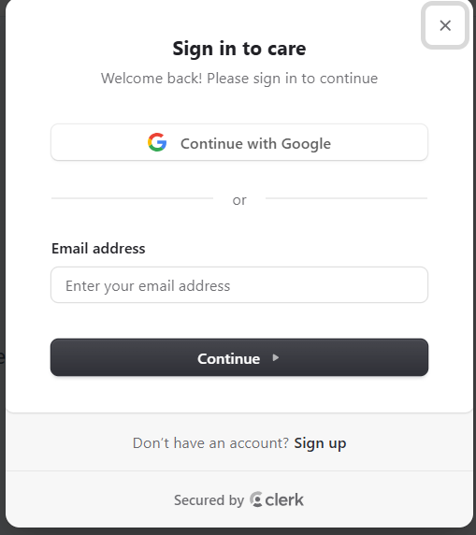
Figure 5 User Login.

4.1.2 Appointment Booking Form.
This screen allows patients to submit appointment requests. The user provides required information such as the doctor to be consulted, the appointment date, and the preferred time slot. Once submitted, the information is stored in the database and awaits approval by the administrator.

4.1.3 Dashboard Screen
The dashboard displays all essential appointment-related records. Patients can view their pending, approved, or declined appointments, while administrators and doctors can view daily schedules. The data is displayed in an organized table format to ensure easy monitoring and follow-up.
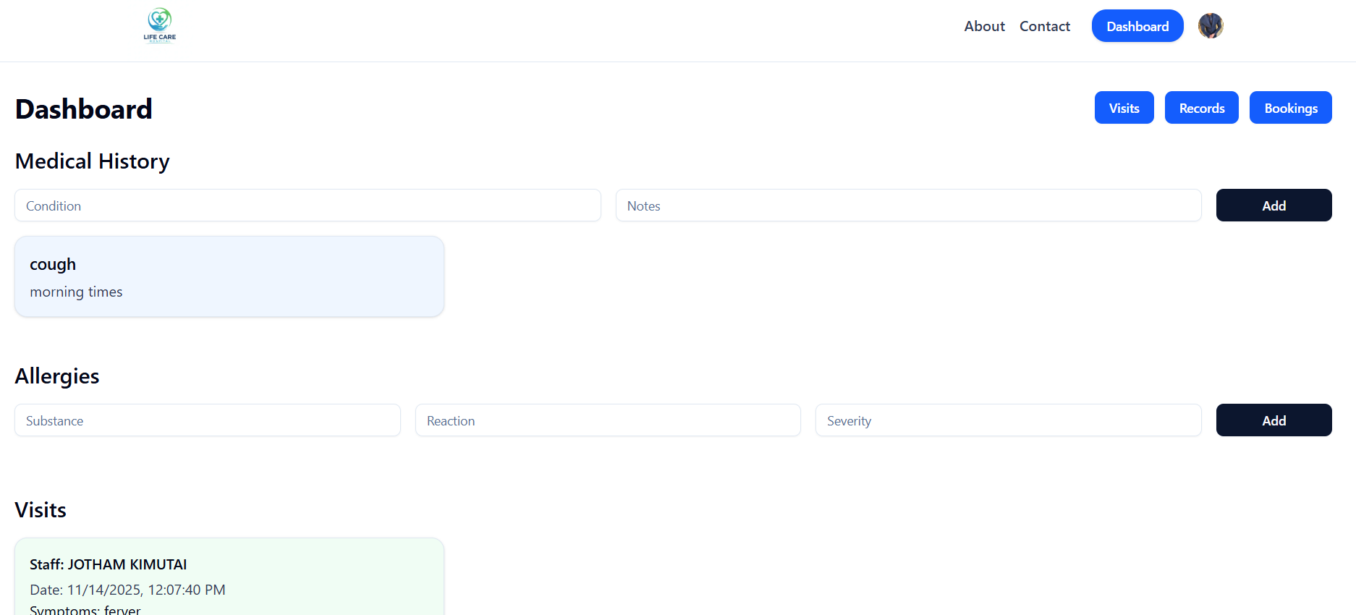
Figure 6 Dashboard Screen.

4.1.4 Admin module.
The admin module manages system operations such as creating user accounts, viewing system activity, and monitoring appointments.
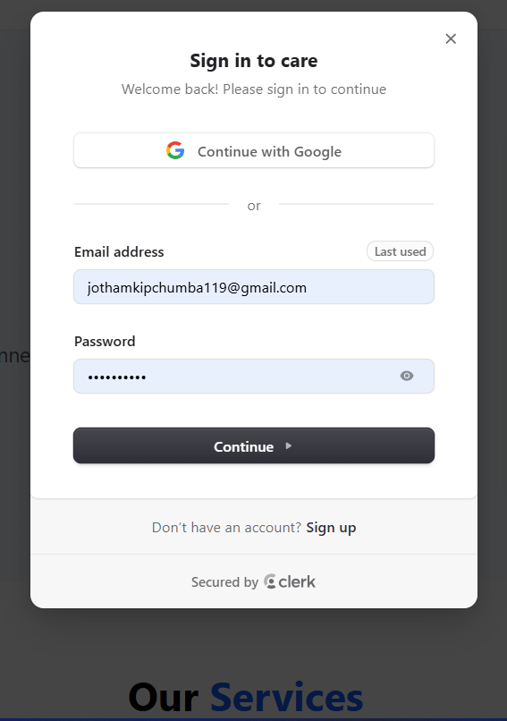
Figure 7 Admin login page.

4.1.5 Admin dashboard.
The Admin Dashboard provides an overview of key system activities, including total users, active appointments, and system notifications. It serves as the central control panel where the administrator can navigate to different management functions.
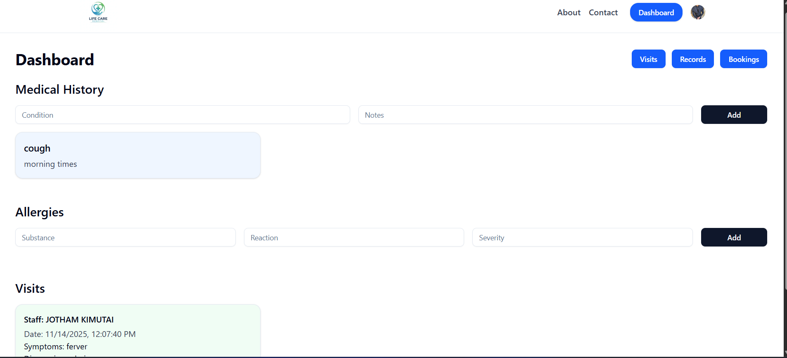
Figure 8 Admin Dashboard.

4.1.6 Manage User Pages.
The Manage Users page allows the system administrator to view, add, edit, and remove user a. It displays a list of all registered users such as patients, doctors, and other staff members, along with their roles and account status. This interface helps the admin maintain accurate user records and control access rights within the system.
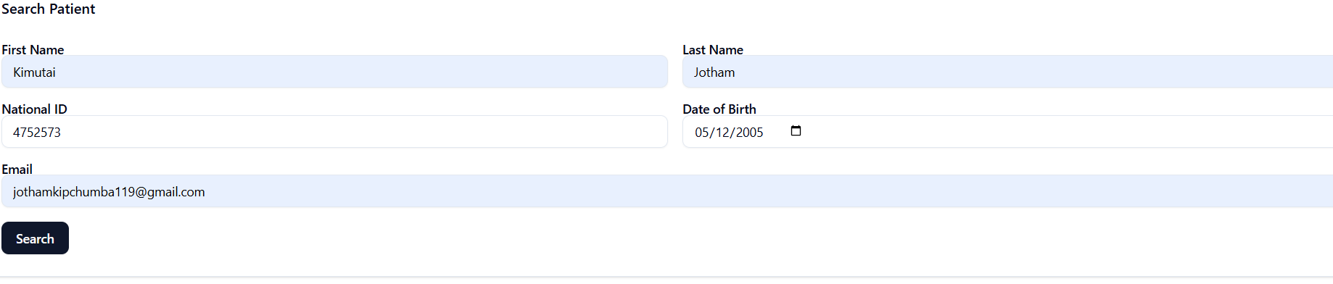
Figure 9 manage user pages.

4.1.7 Appointment overview page.
This page displays all scheduled appointments in the system. The admin or doctor can view patient details, appointment dates, times, and the current status of each booking. It also allows the user to approve, update, or cancel appointments as needed.
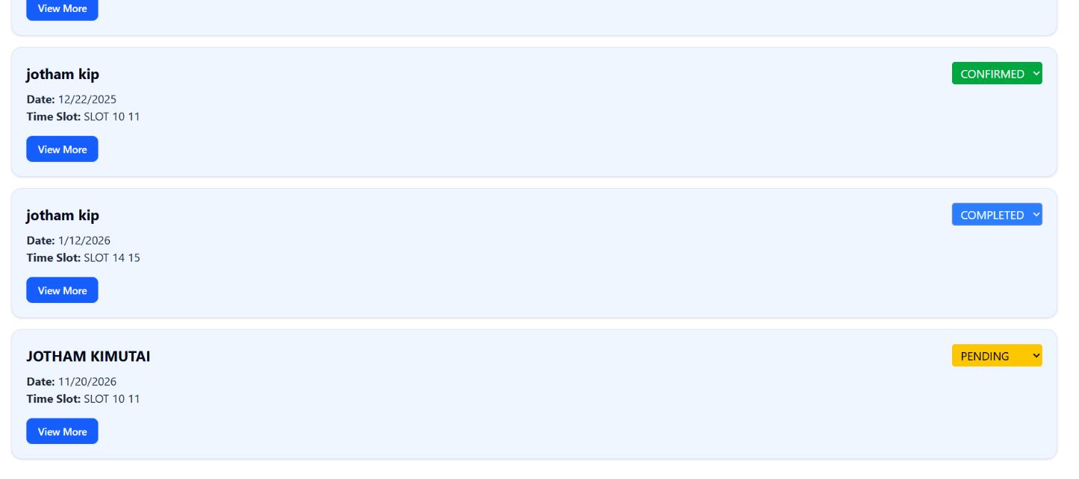
Figure 10 Patient bookings.

4.1.8 Doctor’s Module.
The Doctor Login page allows registered doctors to securely access their personalized system dashboard. It ensures that only verified medical practitioners can view patient information and manage appointments.
Doctors use this module to view appointments, access patient details,upload prescriptions and update consultation notes.
Figure 11 Doctor’s login page.

4.1.9 Doctor’s dashboard.
This dashboard provides doctors with quick access to upcoming appointments, patient lists, and consultation history. It helps doctors manage their daily workflow efficiently and access the tools needed for patient care.
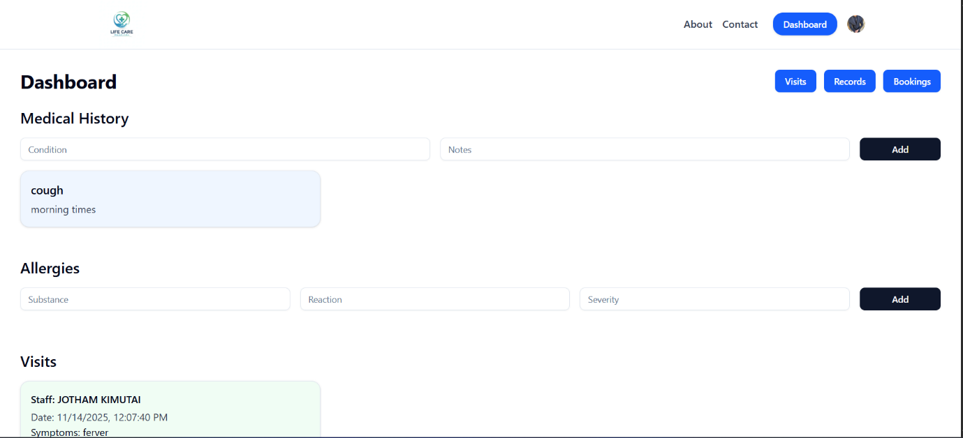
Figure 12 Doctor’s dashboard.

4.1.10 Viewing Appointment Schedule.
This page displays the doctor’s full appointment schedule, including patient names, appointment times, and consultation statuses.
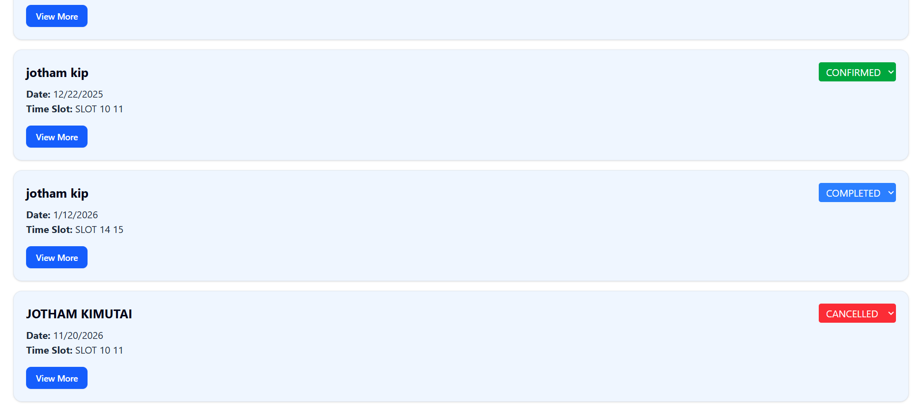
Figure 13 Viewing Appointment Schedule.

4.1.11 Patient Module.
The patient module allows patients to register, log in, book appointments, and check their appointment status. This page allows new patients to create an account by entering their personal details. It ensures that each patient has a unique profile for booking appointments and accessing healthcare services.
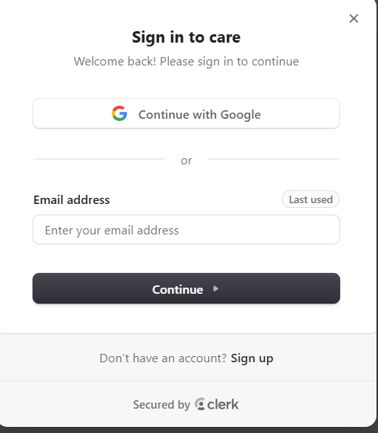
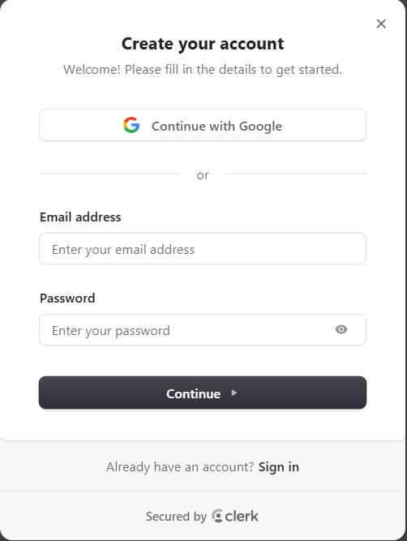

Figure 14 Patient register& login

4.1.12 Appointment Booking Page.
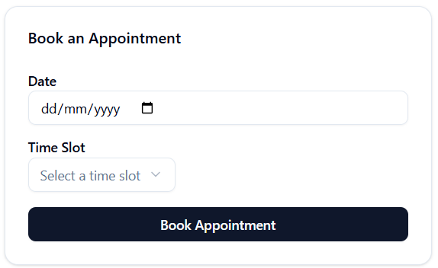
Figure 15 Appointment booking page.
This interface allows patients to schedule an appointment by choosing a date and time, and submitting a request. It simplifies the booking process and reduces the need for physical hospital visits.

4.1.13 Appointment Status Page.
The Appointment Status page shows the patient’s scheduled, pending, or completed appointments. It helps patients track the progress of their bookings and know when their appointment has been approved or updated.
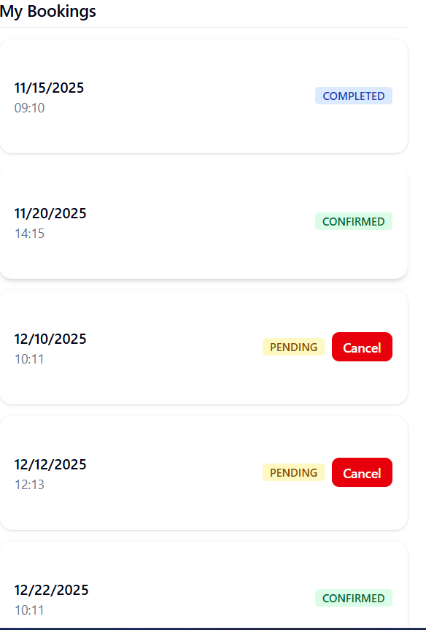
Figure 16 Appointment status page.

4.2 Description of the Implementation.
This section describes how the system was implemented and how it works.

4.2.1 Hardware Specification.
The system requires standard computing resources to run efficiently. The recommended hardware specifications include, Minimum storage 8GB, RAM 2GB, Processor Quad-core CPU, Display Standard monitor with at least 1024×768 resolution. The database is hosted on the HASM server and is accessible 24/7 through a local area network or over the internet, depending on deployment.

4.2.2 Software Specification.
The Hospital Appointment Management System was developed using web-based technologies including php/node.js, html, css and JavaScript. The system is hosted locally using XAMPP during development and testing. Internet or LAN connectivity is required for multi-user access.

4.3 Description of Testing and Results.

4.3.1 System Testing.
The Hospital Appointment Management System was tested using the black-box testing approach. This method examines whether the system meets its functional requirements without considering the internal code structure. It focuses on verifying that system outputs match the expected results based on the requirements specification.

4.3.2 Testing and Data Results.
The table below presents the results of testing for both functional and non-functional requirements.
Table 2 Testing and Data results.
Module | Test carried out | Result of the test
User login | Check if the system allows valid login | Login successful
User login | Check login with invalid credentials | Invalid username or password
Appointment booking | Enter valid appointment details | Appointments submitted successfully
Dashboard display | Check if submitted appointments appear on dashboard | Data displayed correctly

4.3.3 Non-Functional Requirements.
Table 3 Non-Functional requirements.
Module. | Test carried out. | Result of the test.
usability | Check if interface is user friendly | Interface easy to navigate
Reliability | Test system behaviour under normal use | No crashes or interruption s
Performance | Measure response time for user actions | Fast and responsive
security | Attempt access without login | Access denied
maintainability | Make minor system updates | System continued functioning smoothly

4.4.4. Description of Results.
The tests conducted on the system verified both functional and non-functional aspects to ensure optimal system performance. Results showed that the system responded quickly and processed appointment requests efficiently. The user interface was intuitive and simple to navigate for all categories of users. The system also proved to be reliable and secure, preventing unauthorized access. Overall, the Hospital Appointment Management System performed efficiently when compared to traditional manual procedures, which often result in delays, scheduling conflicts, and long queues in the hospital. HASM eliminates these challenges by automating the appointment process and providing real-time updates to both patients and administrators.

CHAPTER FIVE.

CONCLUSION AND RECOMMENDATION.

5.0 Introduction
This chapter provides a summary of the findings obtained after the development, implementation, and testing of the Hospital Appointment Management System (HASM). It highlights the conclusions drawn from the project and offers recommendations regarding the use, improvement, and future enhancement of the system. The chapter also provides directions for potential future work that can build upon the functionalities of the developed system.

5.1 Conclusion
The study successfully developed a Hospital Appointment Management System aimed at addressing the limitations associated with the traditional manual appointment process. The findings revealed that the manual system was characterized by long queues, delayed access to services, high chances of record loss, and inefficient communication between patients and healthcare providers. The implementation of HASM provided a practical solution by digitizing the appointment workflow. The system enabled patients to conveniently book appointments online, reduced congestion within hospital premises, enhanced the accuracy of appointment records, and improved the management of doctors’ schedules. Administrators were able to approve, decline, and monitor appointment requests more efficiently, enhancing the overall coordination of hospital operations. The project demonstrated that an online appointment system significantly improves service delivery in healthcare facilities by increasing efficiency, minimizing human error, and promoting timely access to medical services. The system therefore meets its intended purpose and provides a foundation for modernized healthcare operations

5.2 Recommendation.
It is recommended that the Hospital Appointment Management System be fully adopted by healthcare facilities to improve efficiency in appointment scheduling and patient management. Proper training should be provided to staff and administrators to ensure smooth operation, while patients should be made aware of the system to encourage its use. Regular maintenance and updates are essential to keep the system secure and reliable. Additionally, integrating features such as automated reminders, mobile access, and reporting tools can further enhance the system’s effectiveness and scalability.

5.3 Future Works.
The system presents several opportunities for further development. Future enhancements could include features such as automated report generation, SMS or email notifications for appointment reminders, and the development of a mobile application for both Android and iOS platforms. Incorporating these features would increase the system’s accessibility, flexibility, and scalability, allowing it to serve a broader range of users and further improve the efficiency of hospital appointment management.

REFERENCES.
Admin, H. (2024, March 10). Managing Hospital Appointments Digitally. Retrieved from https://healthcaretechhub.com
Brown, L. (2023). Hospital Information Systems: Design and Implementation. New York: HealthTech Publishers.
Kariuki, P. N. (2022). Improving Patient Flow Through Online Appointment Systems: A Case Study. Kenya Medical Research Journal, Vol. 4, No. 1, pp. 45–52.
Munyua, J. (2021, July 15). Benefits of Online Healthcare Management Systems. Retrieved from https://ehealthkenya.org
Practical Health IT Training Centre. (n.d.). Learning by Doing: Hospital Management Systems. Retrieved from https://practicalhealthit.com
TARAK Hospital Staff Trained in Digital Appointment Management. (2023, September 20). Retrieved from https://training.healthcare.org

